FTP Server Configuration:

Steps:

1) Open Cisco Packet Tracer and select 2 End Devices (PC device), 1 Switch, 1 Router, 1 Server.

2) Now Connect all the devices using the auto connection.

3) Then configure the IP addresses as per the diagram.

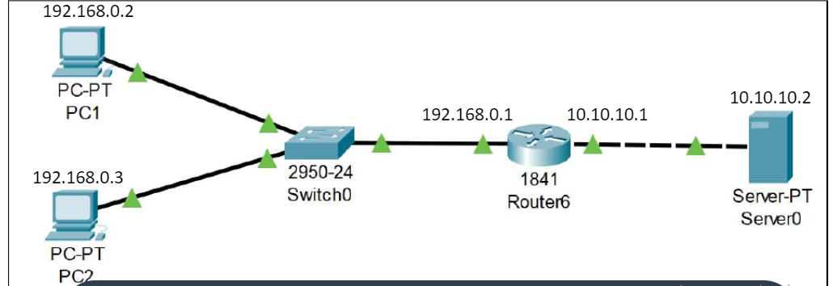

) Now just wait for some time to let all the connection status turns green.

5) Now we have achieved a connection where a class C IP address is being translated to class A IP Address.

6) Go to one of the PC devices and on Desktop tab select CMD.

7) Now we need to check the connection to the server by

8) If reply is coming then it means the server is properly configured and connected.

9) Go to the Server → Services →FTP.

10) Put on the FTP service and give username and password and click on ADD.

11) Come back to PC device and open the CMD and type

12) It will ask for username and password. Provide the username and password configured earlier.

13) Once the connection is established exit rom the CMD and go to Text Editor and make a new text file.

14) Save the new text file and return to cmd and type

15) This will send the text file from the PC device (192.168.0.2) to Server (10.10.10.2).

16) Now to verify that the file has been transferred to the server, so type

17) You will see your Filename in the list.

18) Now to get a file from server to PC type

19) Now exit from FTP type ctrl+C, then type dir to check that the file is there in the PC or not.

20) So we have successfully send and got a file from a server using FTP protocol.

4) Now just wait for some time to let all the connection status turns green.

5) Now we have achieved a connection where a class C IP address is being translated to class A IP Address.

6) Go to one of the PC devices and on Desktop tab select CMD.

7) Now we need to check the connection to the server by C:\>ping 10.10.10.2

8) If reply is coming then it means the server is properly configured and connected.

9) Go to the Server → Services →FTP.

10) Put on the FTP service and give username and password and click on ADD.

11) Come back to PC device and open the CMD and type C:\>ping 10.10.10.2

12) Once the connection is established exit from the CMD and go to Text Editor and make a new text file

13) Type C:\>ftp 10.10.10.2 to connect to ftp server.It will ask for username and password. Provide the username and password configured earlier. Prompt now changes to ftp> i.e. ftp mode

14) Save the new text file and return to cmd and type at ftp prompt, ftp>put filename.txt

15) This will send the text file from the PC device (192.168.0.2) to Server (10.10.10.2).

16) Go to any of ftp client and go to ftp mode and now to verify that the file has been transferred to the server, so type ftp>dir

17) At ftp client You will see your Filename in the list of files existing at FTP server.

18) Now to get(download) a file from server to PC type ftp>get filename.txt

19) Now exit from FTP type ctrl+C, then type dir to check that the file is there in the PC or not.

20) So we have successfully send and got a file from a server using FTP protocol

21) Go to Desktop, click Text editor, File>Open to view file downloaded

DHCP Server Configuration:

1) Open Cisco Packet Tracer and select 2 End Devices (PC device), 1 Switch, 1 Router, 1 Server.

2) Now Connect all the devices using the auto connection.

3) Then configure the IP addresses as per the diagram.

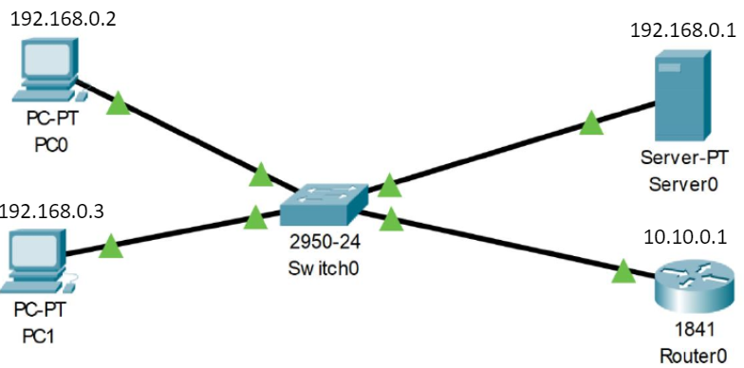

Now just wait for some time to let all the connection status turns green.

5) Now go to the server → Desktop → IP Configuration and set the IP 192.168.0.1.

6) Go to Services → DHCP and set Default Gateway 192.168.0.1 and DNS Server 10.0.0.1. (required only if our network need to be connected to external network, Router0 act as default router)

7) Set the Start IP 192.168.0.0 and Max Users 256

8) Now go to every PC device → Desktop → IP Configuration and set it to DHCP.

9) Now all the PC will have a DHCP address. Check IP of each PCs

10) Add now one more PC, PC2 and connect to Switch. Set PC device → Desktop → IP Configuration and set it to DHCP. After some time, you will see PC2 will get an IP from the block 192.168.0.0 to 192.168.0.255

FTP packet exchange (from Fourozan) Example 21.3 page 641-642

example of how an image (binary) file is stored.

1. After the control connection to port 21 is created, the FTP server sends the 220 (service

ready) response on the control connection.

2. The client sends the USER command.

3. The server responds with 331 (user name is OK, a password is required).

4. The client sends the PASS command.

5. The server responds with 230 (user login is OK).

6. The client issues a passive open on an ephemeral port for the data connection and sends the

PORT command (over the control connection) to give this port number to the server.

7. The server does not open the connection at this time, but prepares itself for issuing an active

open on the data connection between port 20 (server side) and the ephemeral port received

from the client. It sends the response 150 (data connection will open shortly).

8. The client sends the TYPE command.

9. The server responds with the response 200 (command OK).

10. The client sends the STRU command.

11. The server responds with 200 (command OK).

12. The client sends the STOR command.

13. The server opens the data connection and sends the response 250.

14. The client sends the file on the data connection. After the entire file is sent, the data connection

is closed. Closing the data connection means end-of-file.

15. The server sends the response 226 on the control connection.

16. The client sends the QUIT command or uses other commands to open another data connection

for transferring another file. In our example, the QUIT command is sent.

17. The server responds with 221 (service closing) and it closes the control connection.